1. Write a java program to write the data into a file and read back using FileOutputStream/FileInputStream and also try the same using the BufferedReader and BufferedWriter
2. Write a java program to check the file owner details.
3. Write a java program to copy data from one file to another file.

Answers

1.



Example for FileInputStream:

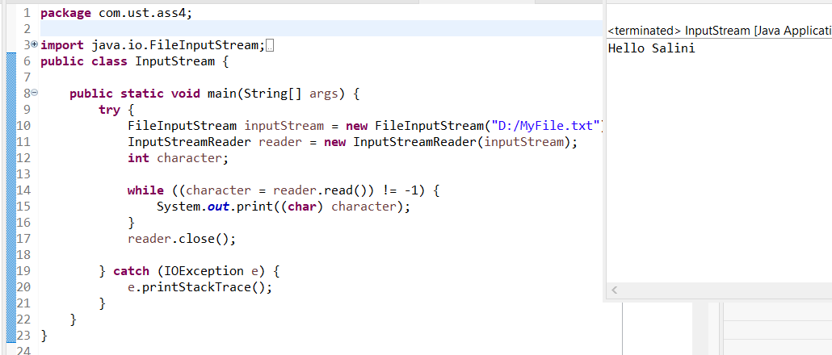

Example for BufferedWriter:



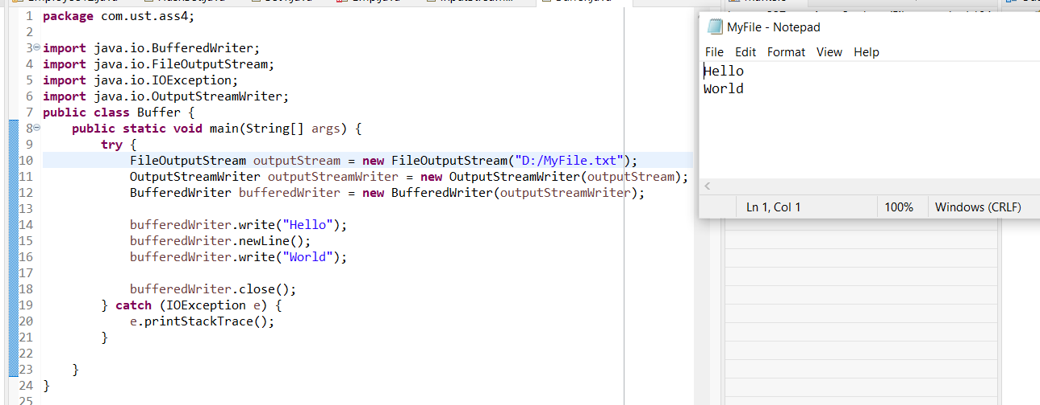

2.



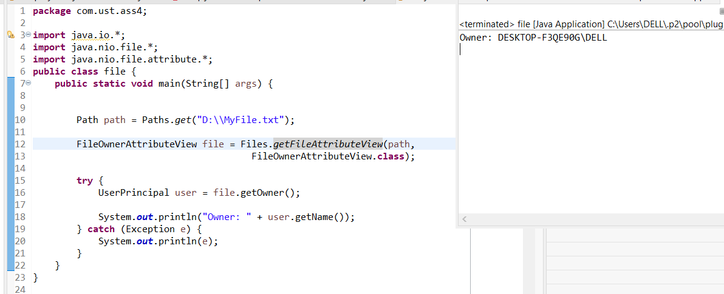

3.

